KARUNYA INSTITUTE OF TECHNOLOGY AND SCIENCES
(Declared as Deemed to be University under Sec. 3 of the UGC Act 1956)
A CHRISTIAN MINORITY RESIDENTIAL INSTITUTION
AICTE Approved & NAAC Accredited
Karunya Nagar, Coimbatore - 641 114, Tamil Nadu, India

GUIDELINES FOR THE PREPARATION OF SYNOPSIS

Synopsis should outline (a) the research problem, (b) the methodology used for tackling it, and (c) the summary of the findings. The size of Synopsis should not exceed 15 pages of typed matter reckoned from the first page to the last page including the List of Publications. The sequence in which the Synopsis should be arranged is as follows:
- Cover Page and Title page (as shown in the Appendix1)
- Text divided into suitable Headings (numbered consecutively)
- References (not more than15)
- List of Publications (those published/accepted for publication in Journals and papers presented in Conferences/ Symposia)

Standard A4 size White Bond paper should be used for preparing the copies. The Synopsis should have the following page margins:

Top edge Bottom edge Left side Right side
: 30 to 35mm
: 25 to 30mm
: 35 to 40mm
: 20 to 25mm

One and a half spacing should be used for typing the general text. The general text shall be typed in Font Style Times New Roman and Font Size 13. One
or two Tables/Figures may be included at appropriate
Places in the text and
they

should conform to the
margin specifications.
All page
numbers (Arabic numbers)

should be typed without punctuation on the central bottom of each page. Synopsis should be bound with black calico cloth and using flexible covers of thick white art paper. The cover should be printed in black letters and the text for printing should be identical to what has been prescribed for the title page (Appendix 1).

REFERENCES

Abdou. L., Ami Saada. R., Meftah. F. and Mebarki. A. (2006) “Experimental investigations of the joint-mortar behaviour”, Mechanics Research Communications 33, 370-379.

Central Ground Water Board Ministry of Water Resources Government of India. (2010) “Groundwater Quality in Shallow Aquifers of India”, Faridabad.

Deodhar.S.V. and Patel.A.N. (1996) “Behavior of brick masonry in compression” Journal of Structural Engineering 22, 221-227.

Mitsch. W.J. and Gosselink. J.G. (1993) Wetlands, Second Edition, Van Nostrand Reinhold, New York, 110-111.

Sarangapani. G., Venkatarama Reddy. B.V. and Jagadish. K.S. (2009) “Structural characteristics of bricks, mortars and masonry” Journal of Structural Engineering 29 (2),101-110.

Tomazevic. M. (2009) “Shear resistance of masonry walls and Eurocode 6: shear versus tensile strength of masonry”, Materials and Structures 42, 889-895.

Wong. Y. L., Lam L., Poon. C. S. and Zhou. F. P. (1999) “Properties of fly ash- modified cement mortar-aggregate interfaces”, Cement and Concrete Research 29, 1905-1911.

APPENDIX 1

A typical Specimen of Cover Page and Title Page
<Font Style Times New Roman>

TITLE(should be in capital letters)
<Font Size 16><1.5 line spacing>

A SYNOPSIS
<Font Size 14>
submitted by
<Font Size 14><Italic>

SCHOLAR’s NAME(Reg. No.)
(previous degree Certificate Name only, Qualification should not be mentioned)
<Font Size 16>

in partial fulfillment for the requirement of award of the degree of
<Font Size 14><Italic><1.5 line spacing>

DOCTOR OF PHILOSOPHY

in

under the supervision of
<Font Size 14><Italic>
SUPERVISOR’s NAME (Qualification should not be mentioned)
<Font Size 16>
and the joint supervision of
<Font Size 14><Italic>
JOINT SUPERVISOR’s NAME (Qualification should not be mentioned)
<Font Size 16>

SCHOOL OF ENGINEERING & TECHNOLOGY/ SCIENCES, ARTS, MEDIA & MANAGEMENT /AGRICULTURE & BIOSCIENCES (font size16)

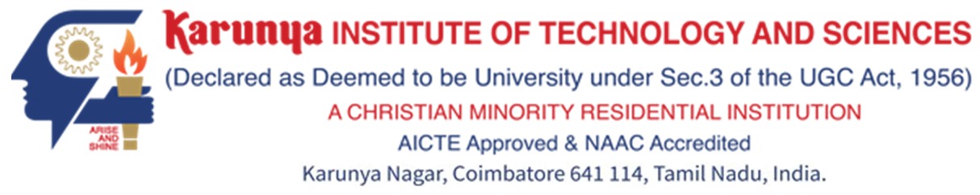

DECEMBER 2017 (should be in capitals Font Size 16)

INVESTIGATIONS ON MACHINING OF Al-TiB2 METAL MATRIX COMPOSITES USING MINIMAL QUANTITY LUBRICATION

A SYNOPSIS

submitted by
ROBERT L (09ZB021)
in partial fulfillment for the requirement of award of the degree of
DOCTOR OF PHILOSOPHY
in
MECHANICAL ENGINEERING
under the supervision of
Dr. CHRISTY T V
and the joint supervision of
Dr. ROBINSON SMART D S

SCHOOL OF ENGINEERING & TECHNOLOGY

DECEMBER 2017

